**Cognizant Deep Skilling Mandatory Hands-On Questions**

**TOPIC- Logging using SLF4J**

Exercise 1: Logging Error Messages and Warning Levels

Task: Write a Java application that demonstrates logging error messages and warning levels using SLF4J.

Ans)

STEP 1: Create a Maven Project and add SLF4J and Logback Dependencies in pom.xml:

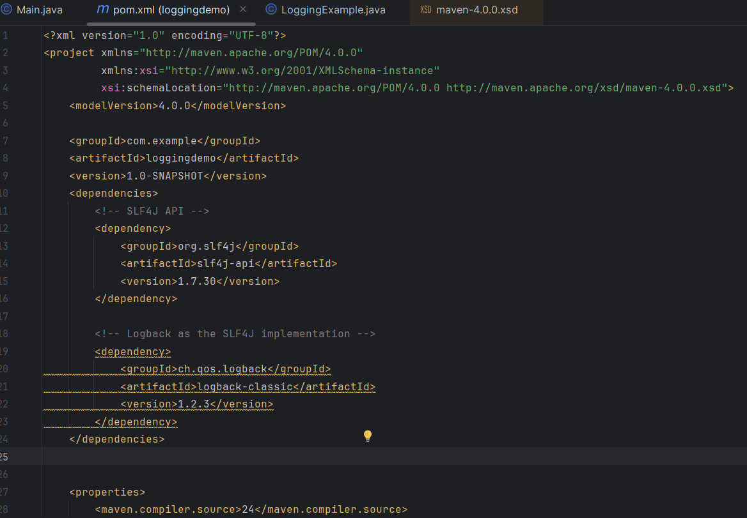

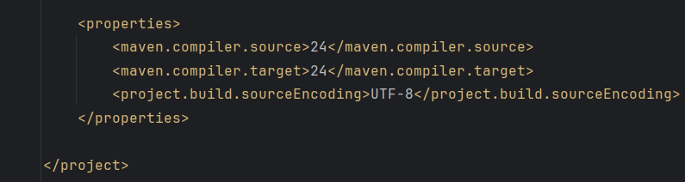

STEP 2: Create the Java Logging Class

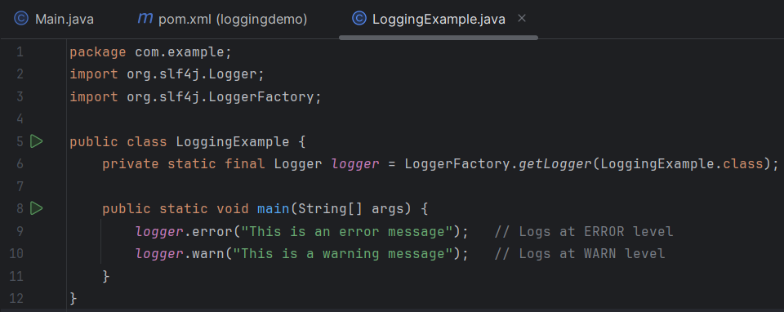

OUTPUT:

